Intro to Databases – Lab Report 03
Student Name: Qasim bin Mehmood
Student ID: AS25SYD006
Course: Intro to Databases
Date: June 12, 2026

Submitted to: Prof. Dinakar Bhotta

Table of Contents
1. Filtering 3
01 3
02 3
2. Grouping By 3
01 3
02 4
03 5
3. Joins 6
01 6
02 6
03 7

1. Filtering

01
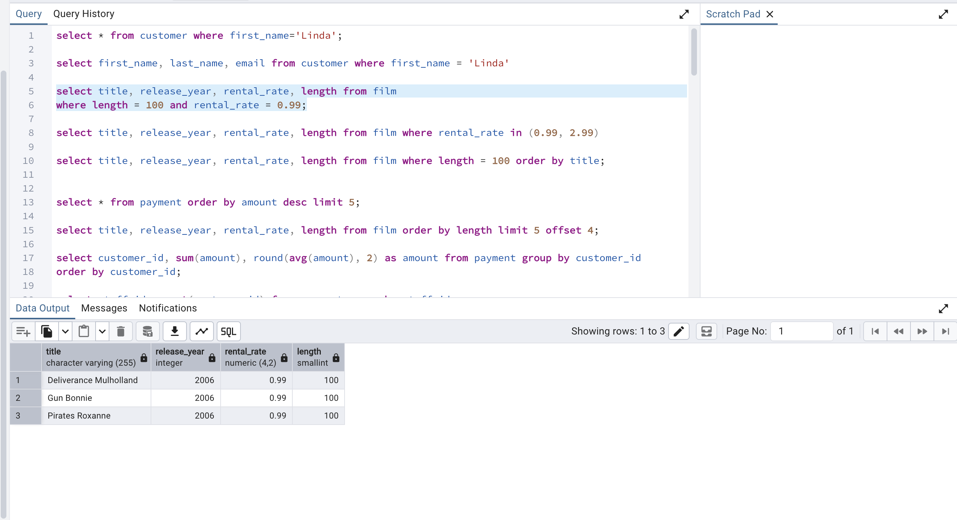

02
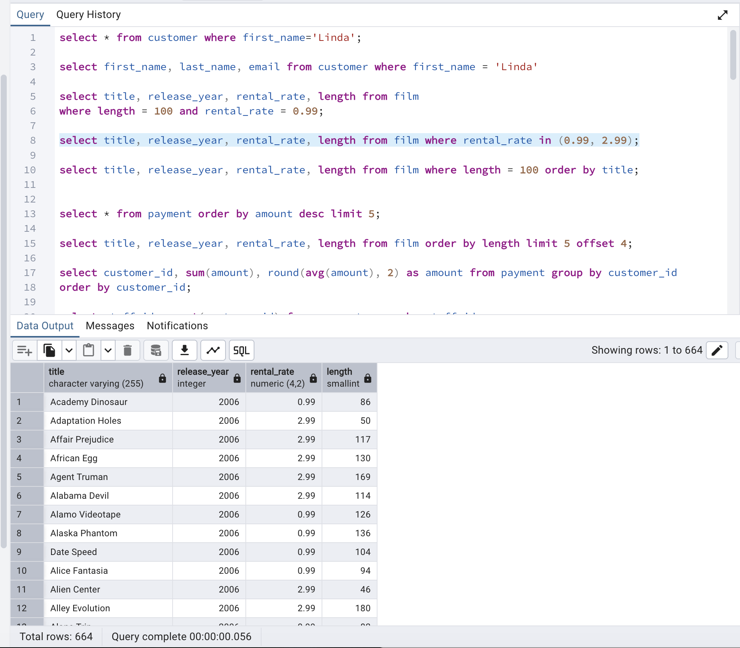

2. Grouping By

01

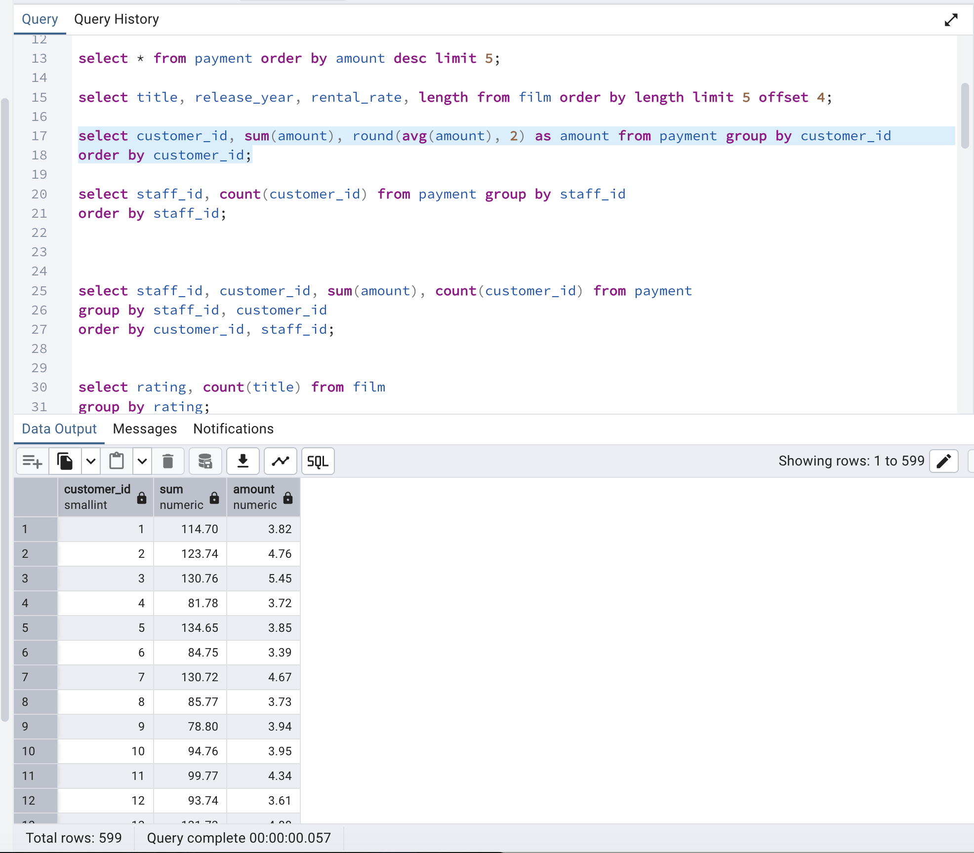
02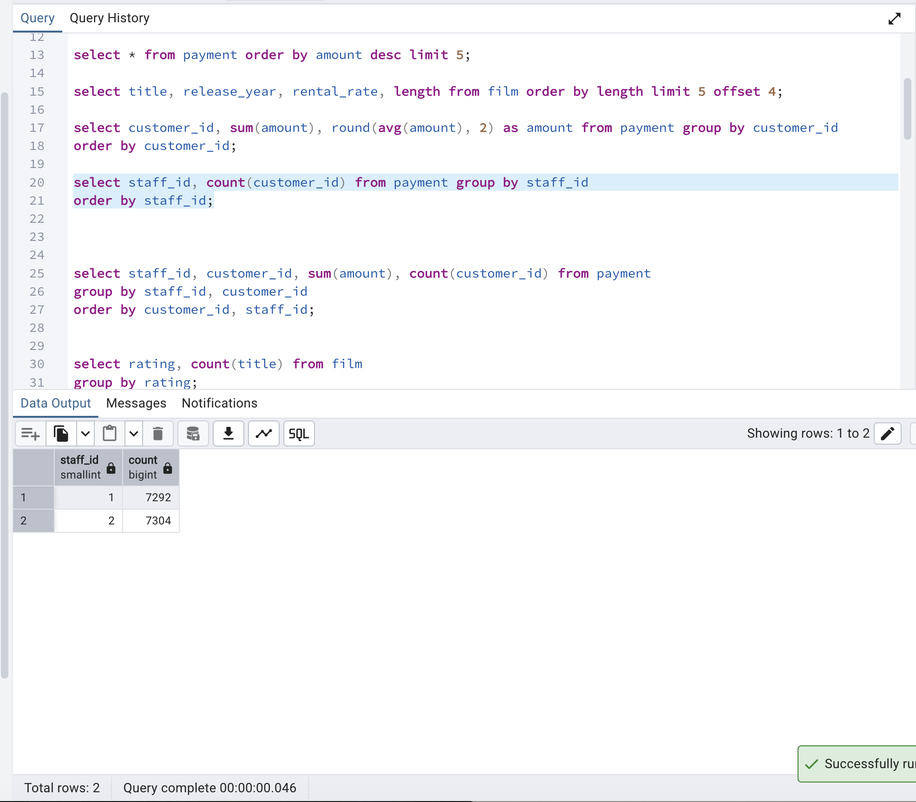
03
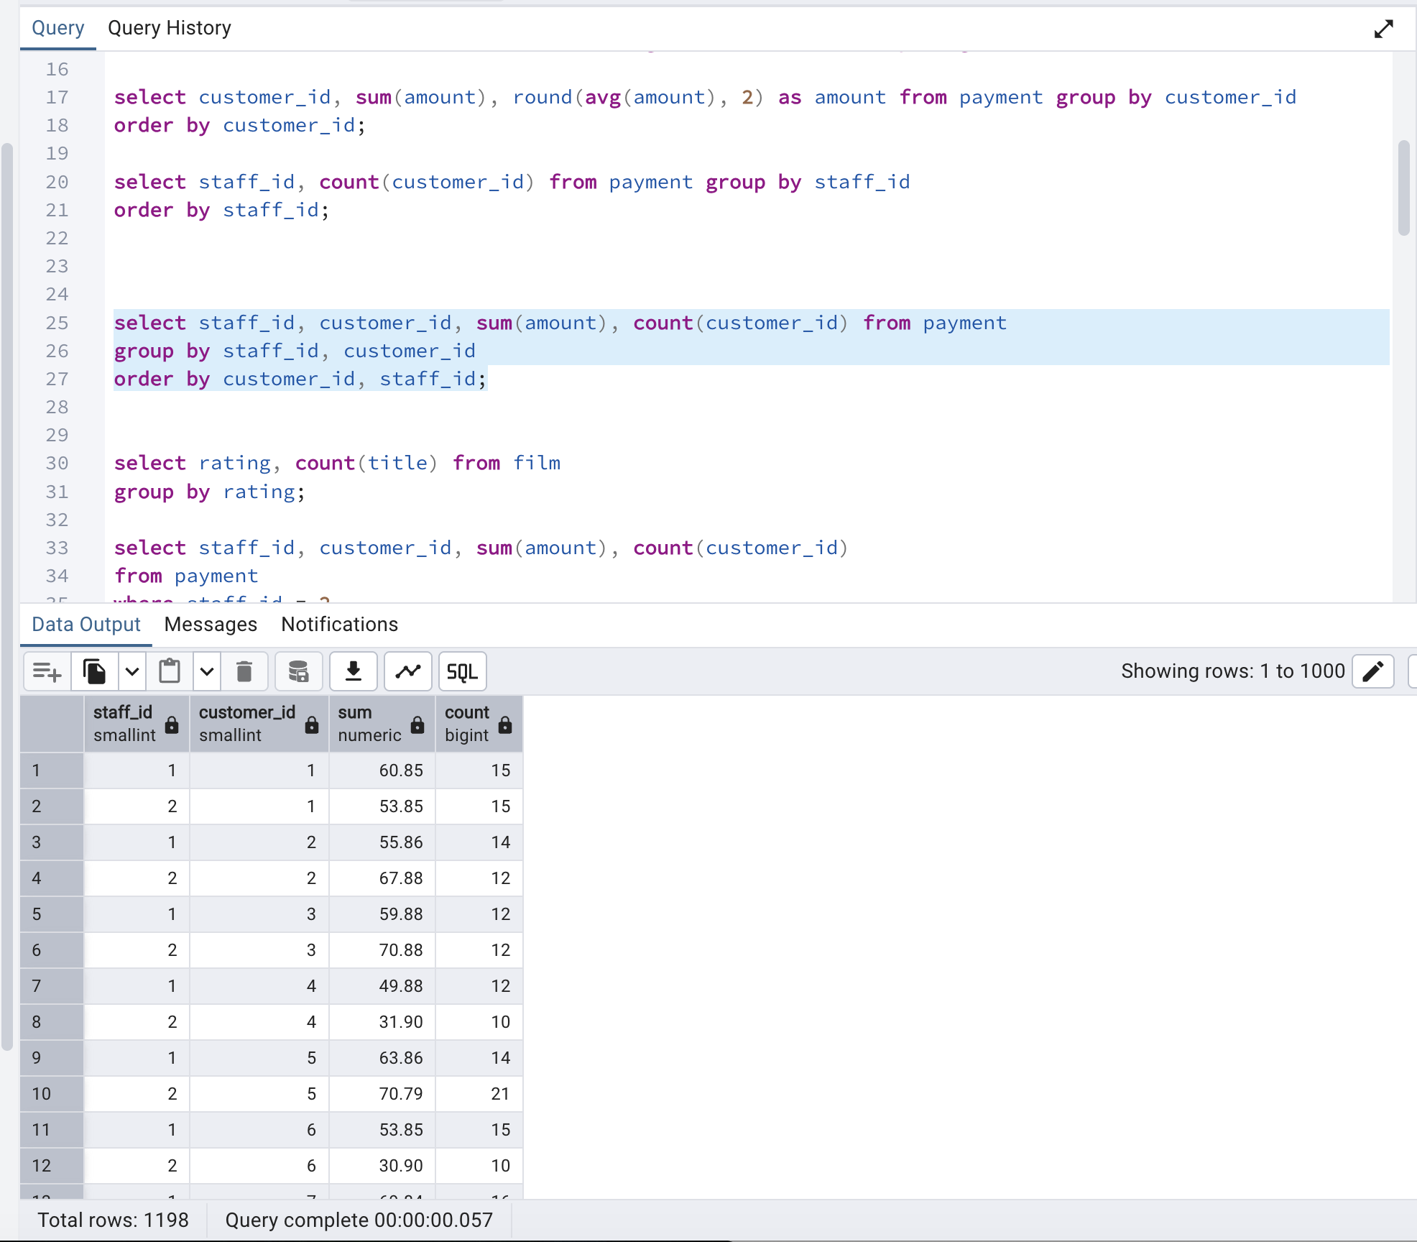

3. Joins

01
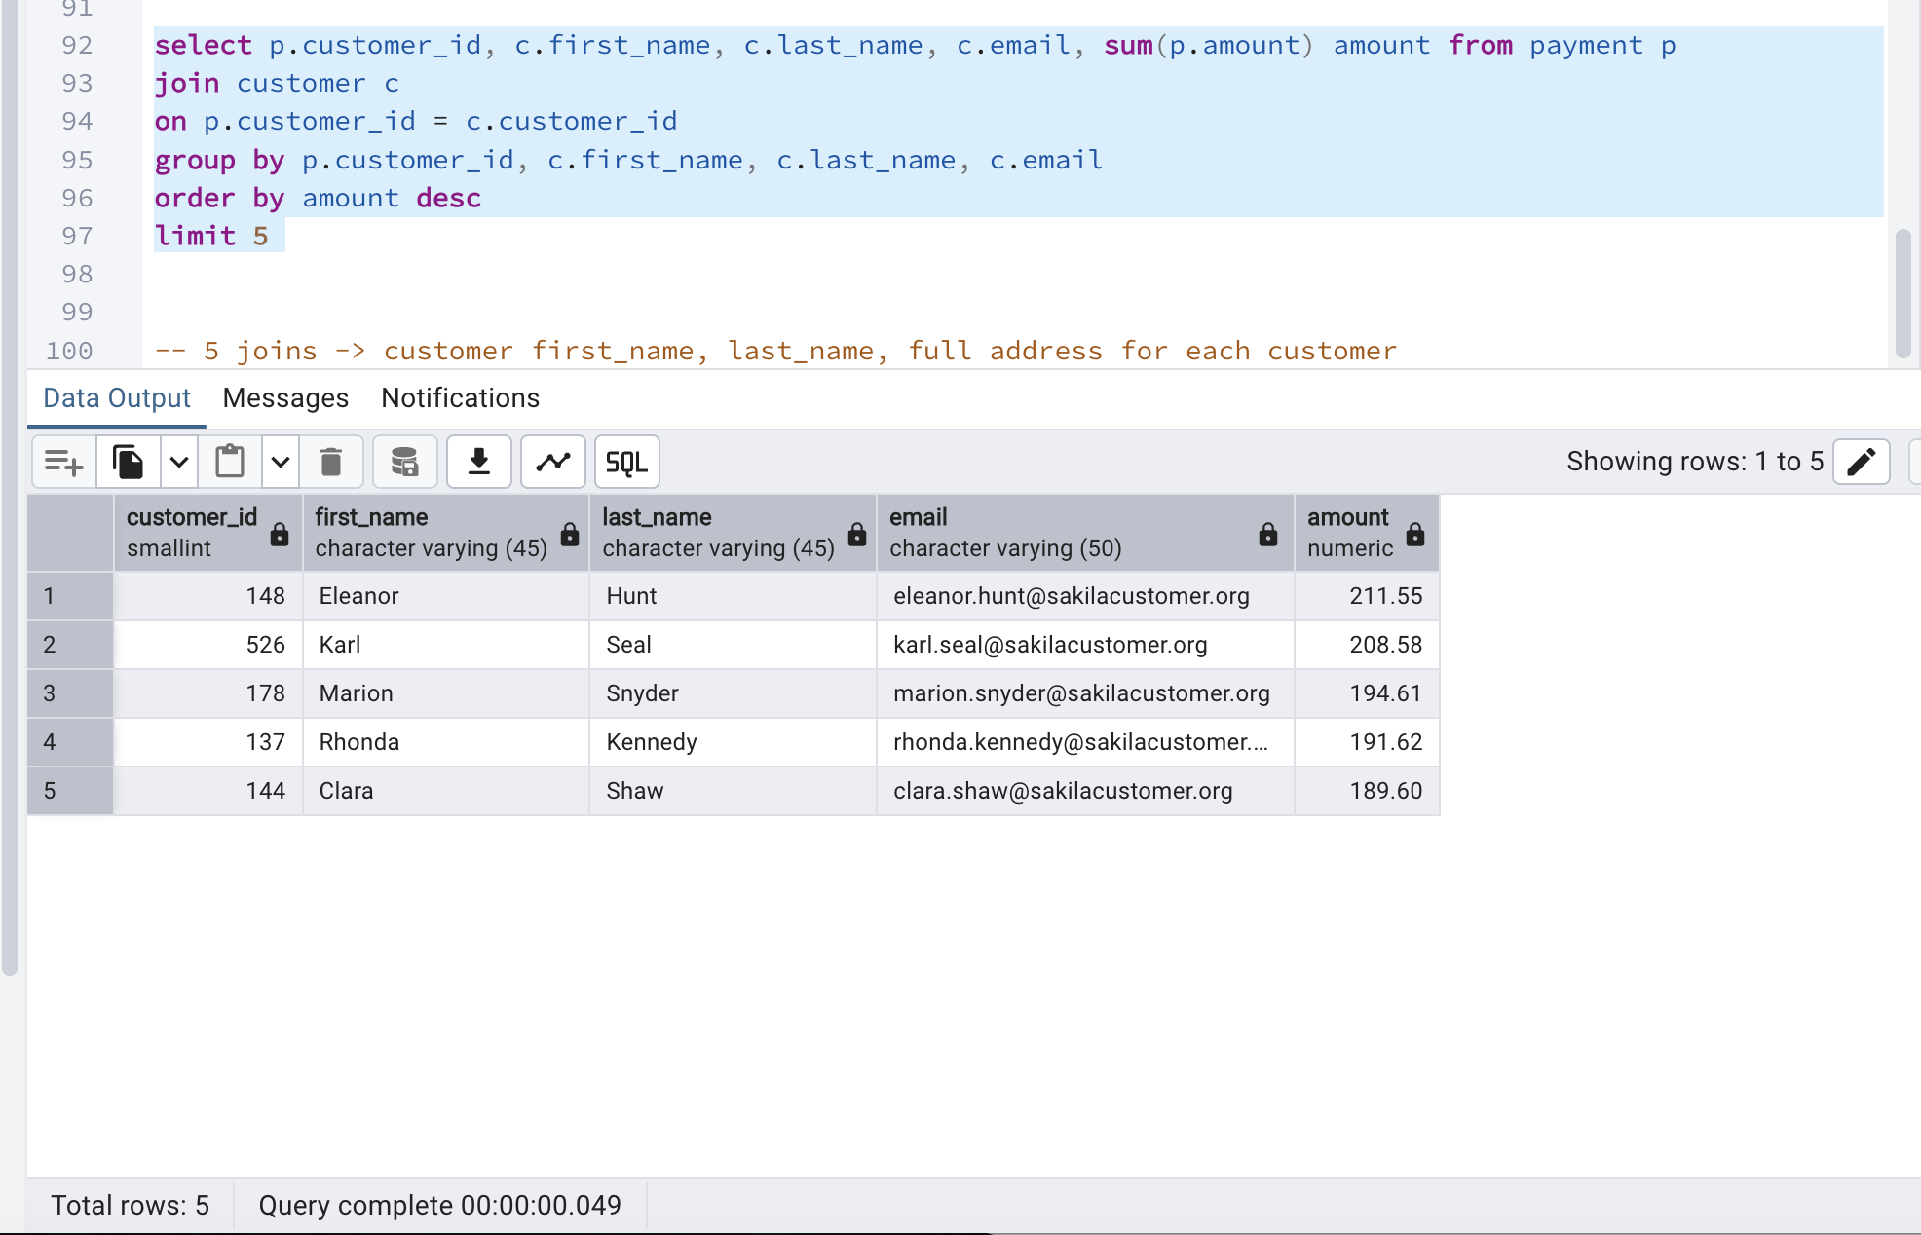

02
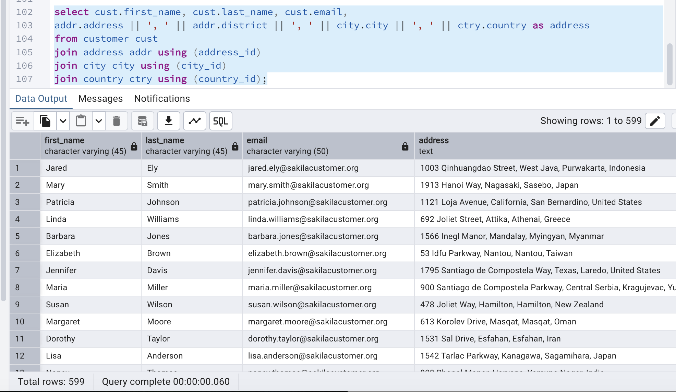

03
